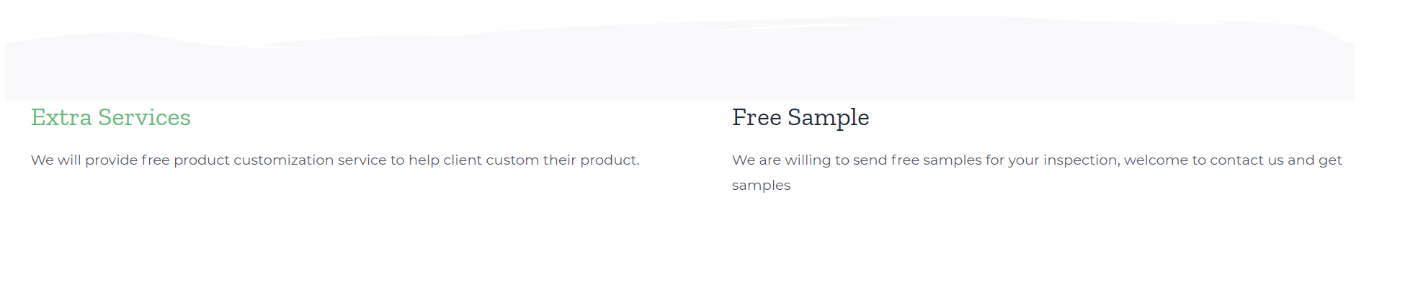

Our Service

Customization: We always provide customize service for each client to meet their requirements.

Free Design: Our designer will provide you with free design.

Free Sample: We will provide free samples for your inspection.

Contact Us form